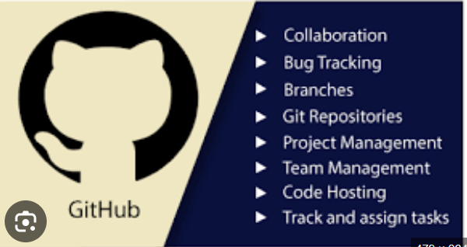

GitHub / Git commands (technically Git commands used with platforms like GitHub):

🔧 Setup & Configuration
- git config --global user.name "Your Name" → Set your username
- git config --global user.email "you@example.com" → Set your email
- git config --list → View current config

📁 Repository Creation & Cloning
- git init → Initialize a new repository
- git clone <repo_url> → Copy a repo from GitHub

📌 Basic Workflow Commands
- git status → Check changes in working directory
- git add <file> → Stage a file
- git add . → Stage all changes
- git commit -m "message" → Save changes with message

🔄 Working with Remote Repositories
- git remote add origin <repo_url> → Link local repo to GitHub
- git push -u origin main → Push code to GitHub
- git pull → Fetch + merge updates
- git fetch → Download changes without merging

🌿 Branching & Merging
- git branch → List branches
- git branch <name> → Create new branch
- git checkout <branch> → Switch branch
- git checkout -b <name> → Create + switch branch
- git merge <branch> → Merge branch into current
- git branch -d <branch> → Delete branch

Viewing History
- git log → Show commit history
- git log --oneline → Compact history
- git diff → Show changes

Undoing Changes
- git restore <file> → Discard local changes
- git reset <file> → Unstage file
- git reset --hard → Reset everything (⚠️ destructive)

GitHub-Specific (via CLI or workflow)
- gh repo create → Create repo using GitHub CLI
- gh pr create → Create a pull request
- gh pr list → List pull requests

